## Objective

## Run an Python-Redis app, and scale, Observe the way docker swarm orchestrates it.

## Steps

## Create the example app and test it with docker compose

## Push the image to the hub.docker.com

## Deploy it via the docker swarm

## Chk the output of the app and troubleshoot it

## Scale the app and chk the output

## To remove the App Env and Cluster

## Create the example application

The app used in this guide is based on the hit counter app in the [Get started with Docker Compose](https://docs.docker.com/compose/gettingstarted/) guide. It consists of a Python app which maintains a counter in a Redis instance and increments the counter whenever you visit it.

1. Create a directory for the project:

$ mkdir stackdemo

$ cd stackdemo

1. Create a file called app.py in the project directory and paste this in:

Make sure the below “intendation” are followed as the Python file is very sensitive to this.

If the copy paste did not, take some effort and rectify it below proceeding further.

from flask import Flask

from redis import Redis

app = Flask(__name__)

redis = Redis(host='redis', port=6379)

@app.route('/')

def hello():

count = redis.incr('hits')

return 'Hello World! I have been seen {} times.\n'.format(count)

if __name__ == "__main__":

app.run(host="0.0.0.0", port=8000, debug=True)

1. Create a file called requirements.txt and paste these two lines in:

flask

redis

1. Create a file called Dockerfile and paste this in:

FROM python:3.4-alpine

ADD . /code

WORKDIR /code

RUN pip install -r requirements.txt

CMD ["python", "app.py"]

1. Create a file called docker-compose.yml and paste this in:

version: '3'

services:

web:

image: vishwacloudlab/stackdemo

build: .

ports:

- "8000:8000"

redis:

image: redis:alpine

The image for the web app is built using the Dockerfile defined above. It’s also tagged with vishwacloudlab.

Later we would be pushing the docker image to central repository , so that all the nodes in the docker swarm cluster can use it.

Note: -- I’m pushing it to my docker hub ID. Make sure you put your ID there.

## Test the app with Compose

1. Start the app with docker-compose up. This builds the web app image, pulls the Redis image if you don’t already have it, and creates two containers.

You see a warning about the Engine being in swarm mode. This is because Compose doesn’t take advantage of swarm mode, and deploys everything to a single node. You can safely ignore this.

$ docker-compose up -d

WARNING: The Docker Engine you're using is running in swarm mode.

Compose does not use swarm mode to deploy services to multiple nodes in

a swarm. All containers are scheduled on the current node.

To deploy your application across the swarm, use `docker stack deploy`.

Creating network "stackdemo_default" with the default driver

Building web

...(build output)...

Creating stackdemo_redis_1

Creating stackdemo_web_1

1. Check that the app is running with docker-compose ps:

$ docker-compose ps

Name Command State Ports

-----------------------------------------------------------------------------------

stackdemo_redis_1 docker-entrypoint.sh redis ... Up 6379/tcp

stackdemo_web_1 python app.py Up 0.0.0.0:8000->8000/tcp

You can test the app with curl:

$ curl http://localhost:8000

Hello World! I have been seen 1 times.

$ curl http://localhost:8000

Hello World! I have been seen 2 times.

$ curl http://localhost:8000

Hello World! I have been seen 3 times.

Bring the app down:

$ docker-compose down --volumes

Stopping stackdemo_web_1 ... done

Stopping stackdemo_redis_1 ... done

Removing stackdemo_web_1 ... done

Removing stackdemo_redis_1 ... done

Removing network stackdemo_default

## Push the generated image to the central repo

## Before you push the image to the remote registry, login to the hub.docker.com on the manager nodes.

## $ docker push vishwacloudlab/stackdemo

To distribute the web app’s image across the swarm, it needs to be pushed to the registry you set up earlier. With Compose, this is very simple:

$ docker-compose push

Pushing web (vishwacloudlab/stackdemo:latest)...

The push refers to a repository [vishwacloudlab/stackdemo]

5b5a49501a76: Pushed

be44185ce609: Pushed

bd7330a79bcf: Pushed

c9fc143a069a: Pushed

011b303988d2: Pushed

latest: digest: sha256:a81840ebf5ac24b42c1c676cbda3b2cb144580ee347c07e1bc80e35e5ca76507 size: 1372

The stack is now ready to be deployed.

## Deploy the stack to the swarm

1. Create the stack with docker stack deploy:

$ docker stack deploy --compose-file docker-compose.yml stackdemo01

Ignoring unsupported options: build

Creating network stackdemo_default

Creating service stackdemo_web

Creating service stackdemo_redis

The last argument is a name for the stack. Each network, volume and service name is prefixed with the stack name.

1. Check that it’s running with docker stack services stackdemo:

$ docker stack services stackdemo

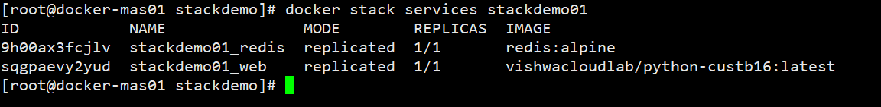

Once it’s running, you should see 1/1 under REPLICAS for both services. This might take some time if you have a multi-node swarm, as images need to be pulled.

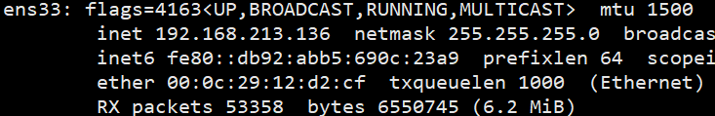

Use the ip of the underline Host VM on which the “web” is running.

$ docker stack ps stackdemo01

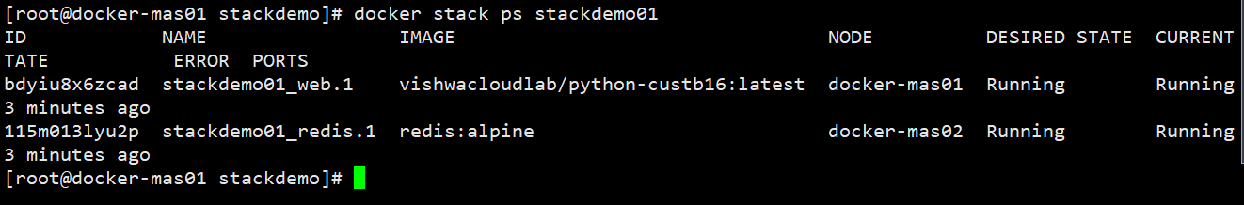

The above command, shows which container is running on which NODE.

Here, **“web”** container is running **“docker-mas01”** node and

**“redis”** container is running **“docker-mas02”** node

As before, you can test the app with curl:

$ curl http://192.168.213.136:8000

Hello World! I have been seen 1 times.

$ curl http://192.168.213.136:8000

Hello World! I have been seen 2 times.

$ curl http://192.168.213.136:8000

Hello World! I have been seen 3 times.

Thanks to Docker’s built-in routing mesh, you can access any node in the swarm on port 8000 and get routed to the app:

$ curl http://address-of-other-node:8000

Hello World! I have been seen 4 times.

## Chk the output of the app and troubleshoot it

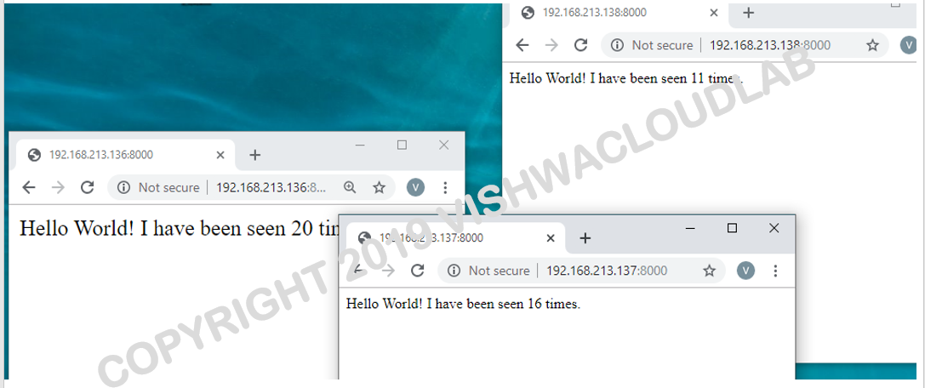

Here I hve used all the ip address of all the NODES in the cluster.

**Troubleshooting:**

IF the output is not coming up and gives an REDIS error, which means the container in Master node01 is not able to communicate to the **redis** container in the “**Master-node02”**.

To solve this problem,

We hve to allow, overlay communication between all the NODES in the cluster.

Open the below ports on all the NODES in the cluster.

1. Port 7946 TCP/UDP for container network discovery
2. Port 4789 UDP for the container overlay network

Commands to be executed on all the VM’s are

$ firewall-cmd --zone=public --permanent --add-port=7946/tcp

$ firewall-cmd --zone=public --permanent --add-port=7946/udp

$ firewall-cmd --zone=public --permanent --add-port=4789/tcp

$ firewall-cmd --zone=public --permanent --add-port=4789/udp

$ firewall-cmd --reload

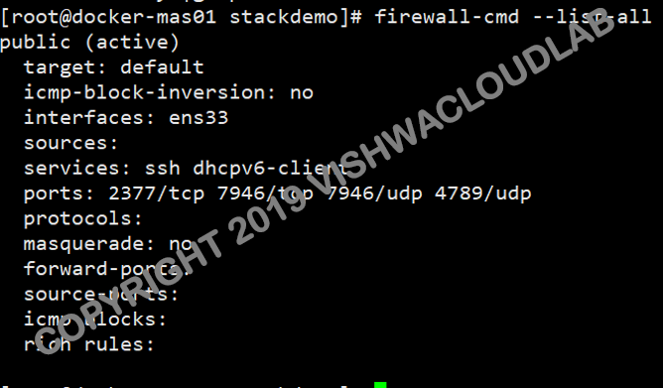

## Scale the app and chk the output

## Check the service details and we would want to scale only the web service

$ docker stack services stackdemo01

## 

## Now, lets scale the web service.

$ docker service scale stackdemo01_web=4



. $ docker stack services stackdemo01

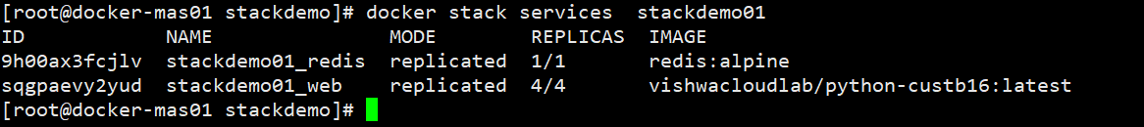

. $ docker stack ps stackdemo01

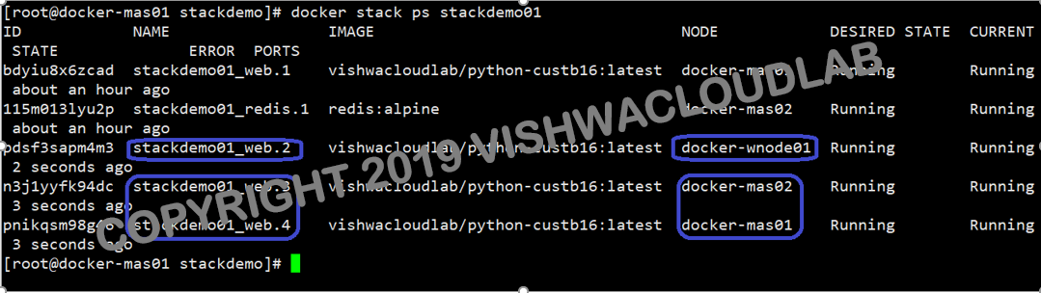

Lets check the output now.

The front end, really no changes, We can still access the app, using any of the IP address of the NODES in the cluster.

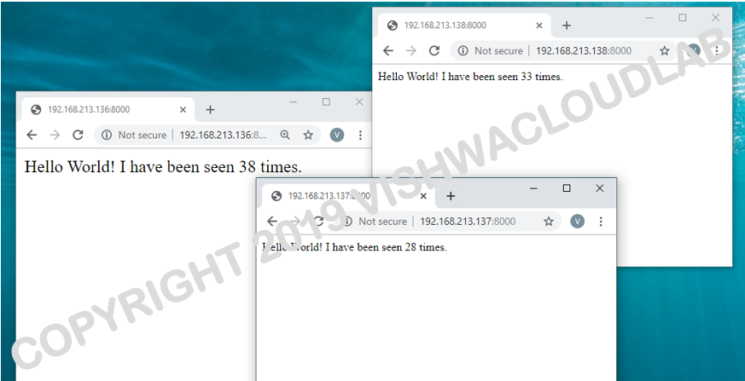

## Remove the stack and cluster

1. Bring the stack down with docker stack rm:

$ docker stack rm stackdemo01

Removing service stackdemo_web

Removing service stackdemo_redis

Removing network stackdemo_default

1. If you’re just testing things out on a local machine and want to bring your Docker Engine out of swarm mode, use docker swarm leave:

$ docker swarm leave --force

Node left the swarm.